* CSS
* Bootstrap
* Communication
* SQL -MongoDB
* Git
* Data Handling
* REST API

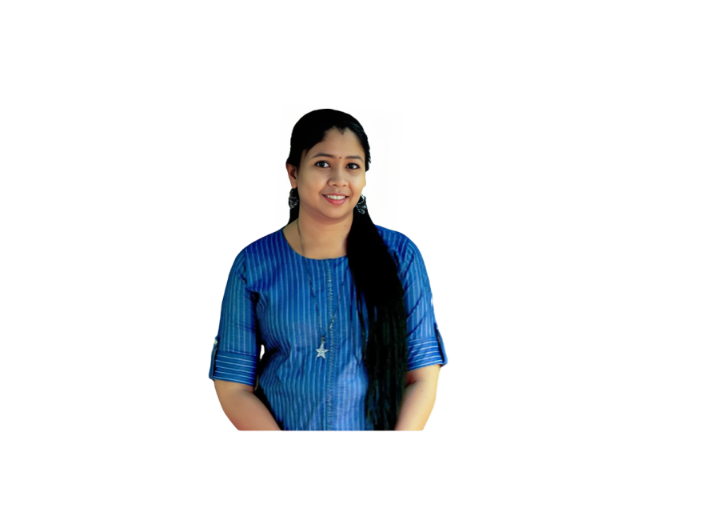

* Full Stack Development
* Python-Django
* Web Applications
* HTML-5

**KEY SKILLS**

**SRUTHI SURESH**

**EXPERIENCE**

**COMPUTER TEACHER** | Al-Ameen Public school, Sreemoolanagaram

**DEVELOPER INTERNSHIP|06/2024 – Present**

SMEC LABS, KOCHI, INDIA.

**KEY RESPONSIBILITIES**

* Developed dynamic web applications using Python-based frameworks such as Django, contributing to the creation of scalable and efficient web solutions.
* Designed and managed relational databases using MySQL, ensuring data integrity and optimal performance.
* Utilized MySQL for database management, including data modeling, query optimization, and schema design.
* Developed and implemented front-end features using HTML, CSS, and JavaScript to create responsive and user-friendly interfaces.
* Integrated front-end components with back-end services to ensure seamless interaction between user interfaces and data.
* Ensured high code quality through regular testing, debugging, and adherence to best practices in Python and web development.
* Identified and resolved bugs and performance issues in web applications, ensuring reliable and efficient operation.
* Utilized version control systems (e.g., Git) for code management, collaboration, and tracking changes throughout the development lifecycle.
* Continuously learned and applied new technologies and best practices in full-stack development to stay current with industry trends and improve technical skill

**CAREER SUMMARY**

Motivated individual with experience in Developer Internship. Gained hands-onexperience in software development, including coding, debugging, and collaborating on projects during the internship. Proficient in a variety of programming languages and frame-works, with a demonstrated ability to deliver scalable, efficient, and user-friendly applications. Adept at utilizing programming languages and development tools to create functional and innovative solutions. Proven ability to bridge technical expertise with educational goals, enhancing both practical coding skills and foundational computer knowledge.

**PERSONAL DETAILS**

Mobile No +919048133580

Email Id [sruthi1000@gmail.com](mailto:sruthi1000@gmail.com)

Address Ettungapady House, Okkal P.O, Perumattom, Ernakulam, Kerala, 683550, India

Nationality Indian

D.O.B 06/05/1990

Gender Female

Marital Status Married

**ACADEMIC CREDENTIALS**

**2024 Python Full Stack Development**

SMECLabs, Kaloor

**2011 BCA (Bachelor of Computer Applications)**

MG University, Union ChristianCollege, Aluva

**2007 HIGHER SECONDARY**

SNHSS OKKAL, Kerala State Board

**2005 SSLC**

St. Joseph GHS Chengal, Kerala State Board

**COMPUTER SKILLS**

* MS Word
* MS Power Point
* Photoshop

**LANGUAGES KNOWN**

* English
* Malayalam

**PROJECT**

* Project: Personal Portfolio - HTML, CSS , Bootstrap
* Doctor Appointment Booking Web Application - HTML, CSS, Bootstrap, Django, Python, SQL
* ToyCart – Ecommerce Web Application – HTML, CSS, Python, Django, Bootstrap, SQL

* Mini – Project (2009): Crime File Management System,Visual Basic &SQL,Windows XP
* Main – Project (2010): Magazine Subscription System,JavaScript,VB.Net,SQL, Windows XP

**REFERENCES**

* Available upon request.

**HOBBIES**

* Music
* Travelling

**DECLARATION**

Hereby declare that all the details mentioned above are in accordance with the truth and fact as per the knowledge.

**SRUTHI SURESH**

**DECLARATION**

I hereby declare that all the details mentioned above are in accordance with the truth and fact as per my knowledge and I hold the responsibility for the correctness of the above-mentioned information

**PRABAKAR SRINIVASAN**